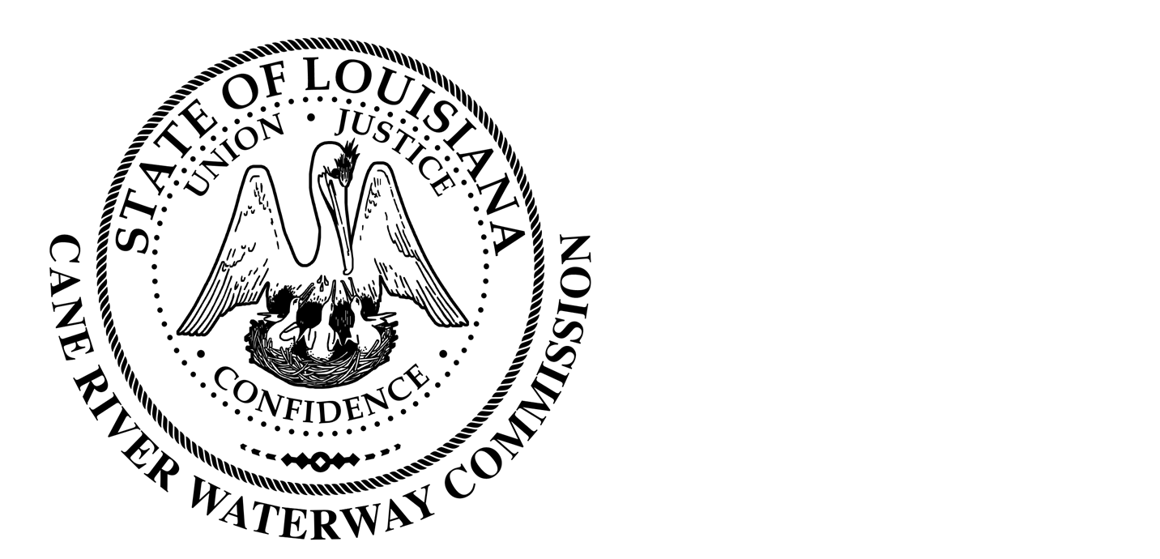

Notice Posted: August 10, 2023 8:00 am

NOTICE OF PUBLIC MEETING

A public meeting will be held as follows:
The Cane River Waterway Commission pursuant to RS 42:14/42:19A will allow a public comment period prior to action on an agenda item upon which a vote is to be taken.

DATE: August 15, 2023
TIME: 6:00 pm
PLACE OF MEETING: 244 Cedar Bend, Natchez Louisiana 71456

AGENDA:
Call to Order
Roll Call
Approval of Minutes from last meeting, June 20, 2023.
Introduction of guest
Treasure’s Report
Executive Session

Old Business
- Roque House Project
- Pump Station
- Washington Street Project

New Business:
- Audit Review
- Natchitoches Parish Fishing Team
- Policy and Procedure
- Ordinance 1 of 2023
- Natchitoches Meat Pie Festival

______________________________
CRWC Director of Operations Jason Adcock
Cane River Waterway Commission
244 Cedar Bend, Natchez Louisiana 71456
318-663-8815

In accordance with the Americans with Disabilities Act, if you need special assistance, please contact Jason Adcock at 318-663-8815 describing the assistance that is necessary.

